Group symbol: 3
Team: 1

Project title: Resource Allocation App

Team members (filled by PM, Team Leader):
No | Name | Surname | Student ID | Role
1 | Carmelo Aidan | Romero | 293936 | PM, Team Leader
2 | Álvaro | Puebla | 293867 | Team member
3 | David | Sosa | 293885 | Team member
4 | Diego | Ceballos | 293943 | Team member
5 | Diego | García | 293939 | Team member
6 | Óscar | López | 293871 | Team member

- Elaboration of application concept (S1)
  - Project (business) goals
Present as a tree of the project’s objectives, i.e., decomposition of general project objective into specific ones. A goal should be:
- relevant to the project,
- important from the perspective of the end-user,
- achievable,
- measurable,
- realistic (achievable in terms of constraints: cost and time-oriented, technological, organizational, human resources, legal).

General objective: Build a university-wide system that lets users reserve, borrow, rent or book any campus resource (books, rooms, equipment, vehicles, study kits), manage approvals and loans, enable physical check-in/out (QR/ISBN/barcode), and show real-time availability and status across campus.
The main goals are:
- Unified resource access
- Enable centralized access to books, rooms, and equipment through a single digital platform, reducing operational complexity and infrastructure cost.

2. Reliable loan & reservation lifecycle
  - Ensure a consistent, reliable borrowing and reservation process across all resource types, increasing user trust and reducing administrative burden.
  - Minimize booking failures and support load by guaranteeing high transaction success rates.
  - Protect resources through automated enforcement of institutional policies (loan duration, quotas, training requirements).

- Accurate physical confirmation
  - Enable precise, device-assisted verification of resource hand-offs to improve accountability and reduce loss or misuse of assets.
  - Reduce asset loss and fraudulent check-outs through authenticated scanning.
  - Automate overdue and no-show handling to save staff time and improve resource turnover.

- Visibility & operational control
- Provide real-time visibility into campus resource availability and usage, empowering staff to optimize asset distribution, maintenance scheduling, and budget planning.
- Improve facility and equipment utilization with live status monitoring.
- Reduce administrative effort through automated reporting, audit support, and exportable usage analytics.

  - Identification of project’s internal and external Stakeholders
Identify the role of each internal stakeholder in the project, along with a textual description.
Symbol | Name | Role | Description
I1 | Carmelo A. Romero | Cross-functional team member | Leads the team, coordinates stakeholders, owns schedule and scope, primary contact for sponsor/IT; also contributes across project tasks as needed.
I2 | Álvaro Puebla | Cross-functional team member | Contributes across planning, development, testing, deployment and documentation as required.
I3 | David Sosa | Cross-functional team member | Contributes across planning, development, testing, deployment and documentation as required.
I4 | Diego Ceballos | Cross-functional team member | Contributes across planning, development, testing, deployment and documentation as required.
I5 | Diego García | Cross-functional team member | Contributes across planning, development, testing, deployment and documentation as required.
I6 | Óscar López | Cross-functional team member | Contributes across planning, development, testing, deployment and documentation as required.

Identify the role of each external stakeholder in the project, along with a textual description.
Symbol | Name | Role | Description
E1 | Students | Primary end users | Search, reserve, borrow materials and rooms; need simple mobile flows and notifications.
E2 | Faculty & Researchers | Power users | Reserve recurring rooms, request equipment for classes/research, need reports and billing integration.
E3 | Library Staff | Resource managers | Manage book inventories, loans, returns, overdue policies; process approvals and holds.
E4 | Facility Managers | Room owners | Approve room bookings, mark rooms unavailable (events, maintenance), provide floorplans.
E5 | Lab/Equipment Managers | Equipment owners | Enforce training-based access, schedule maintenance, and mark equipment status.
E6 | University IT | Integration & security | SSO, directory integration, network policy, hosting support.
E7 | Students’ Union / Admin | Billing & policy | Interested in usage data, fines, and reporting for charges or resource scheduling.

  - Domain description
- Description of phenomena in the application domain that can be observed.
- Definitions of concepts that abstract these phenomena.
- The concepts include:
  - entities – things that one can “distinguish” from the fraction of reality,
  - relationships – either properties (unary relationships of entities) that yield some information about them or relationships between two or more entities (binary or n-ary relations),
  - events – things that can happen (occur).
- Use UML class diagram to depict entities (class with attributes), relationships (associations).
- This diagram must be supplemented with the list of entities, relationships and events along with their description in natural language.

Domain phenomena:
- Multi-type resource lifecycle: Reservation/loan flows differ per type (rooms: timed reservation; books: loan checkout/return; equipment: reservation + check-in/out, possibly training prerequisites).
- Hold/Queue mechanics: When an item is on loan, users can place holds; next eligible user is notified.
- Physical confirmation: Barcode/ISBN/QR scans confirm checks and returns.
- Status propagation: Check-in/out, maintenance, and cleaning events update availability and map visualizations near real-time.
- Overdue & fines: Items unreturned trigger overdue events, notifications, and possibly fines or account blocks.
Definition of concepts:
- User — campus account (student, faculty, staff). (user_id, name, email, role, department, account_status)
- Department — organizational owner of resources. (dept_id, name, contact)
- Resource (abstract) — any lendable or bookable item. (resource_id, type, name, location_id, status, department_id)
- Subtypes: Book (ISBN, shelf_location, copies_available), Room (capacity, floorplan_position), Equipment (serial_number, requires_training), Vehicle, etc.
- Reservation — a booking request for a resource/time window. (reservation_id, user_id, resource_id, start_time, end_time, status, created_at)
- Loan / Checkout — a lending instance (for books, kits). (loan_id, resource_id, user_id, checkout_at, due_at, returned_at, status)
- QRCode / Barcode — physical token linking to resource. (token_id, resource_id, payload)
- CheckEvent — check-in/out record. (event_id, loan_or_reservation_id, user_id, type, timestamp)
- HoldRequest — queued request for a resource copy. (hold_id, user_id, resource_id, placed_at, notified_at)
- MaintenanceEvent — planned maintenance/cleaning for resources or rooms. (maintenance_id, resource_id, start_time, end_time, reason)
- Notification — message (email/push/SMS). (notification_id, user_id, type, body, sent_at)
- Policy — rules that govern loans and reservations (max duration, fines). (policy_id, resource_type, max_duration, fines_per_day)
Entity–relationship model:
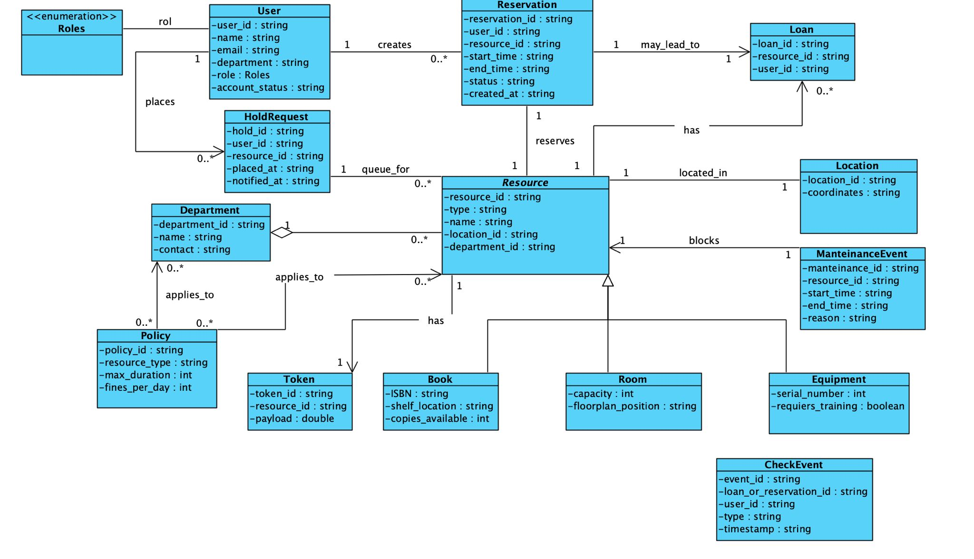
  - Project schedule (Gantt chart)
- tasks with dependencies,
- start time and duration,
- resource allocation: staff, costs, equipment.

Overview: 6-week MVP. Tasks include dependencies, start week (W1 = project start), duration in weeks, primary assigned role, estimated staff-hours and estimated labour cost.
ID | Task | Duration | Depends on | Notes
T1 | Requirements & concept finalization | 1 wk | — | Define resource types and workflows
T2 | Data model & backend setup (API, DB) | 1 wk | T1 | Entities, relations, policies
T3 | Frontend layout & navigation | 1 wk | T1 | React base, pages
T4 | Reservation & loan logic | 1 wk | T2 | Booking + checkout modules
T5 | QR/Barcode scan & map view | 1 wk | T4 | Visual status + room locations
T6 | Notifications & admin panel | 0.5 wk | T4 | Emails, overdue alerts
T7 | Testing, polishing & deployment | 1.5 wks | T5-T6 | QA + Docker deploy
Team effort (approx.): 450 hours
Estimated cost (approx.): €8,000 – €10,000
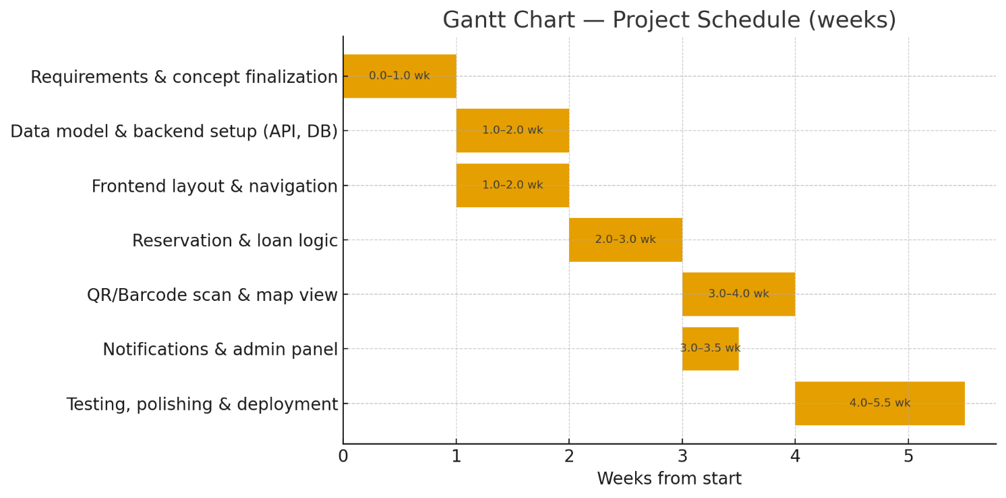
Resources: shared laptops, test phones/tablets for QR scanning, cloud DB & hosting (optional).

  - Identification of existing or alternative solutions
Each competitor should be characterized with
- name of the project/application,
- main features,
- advantages,
- disadvantages.
LibCal (Springshare)
- Main features: Room & equipment booking, calendar integrations, event scheduling, waitlists, reporting, user notifications.
- Advantages: Designed for academic libraries/campuses; polished UX; good customer support and analytics.
- Disadvantages: Commercial (licensing costs); limited backend/customization; vendor lock-in for integrations.
Ex Libris Alma / Primo
- Main features: Full ILS/ERMS (cataloguing, acquisitions, circulation), discovery layer, integrated workflows for library operations.
- Advantages: Enterprise-grade library functionality; strong integration with consortia and library standards.
- Disadvantages: Very heavy/complex; high cost; overkill for simple multi-resource booking (not optimized for rooms/equipment).
Booked Scheduler (phpScheduleIt)
- Main features: Resource & room scheduling, recurring bookings, admin approvals, user accounts, calendar export.
- Advantages: Self-hostable, lightweight, mature open-source roots, fairly simple to customize.
- Disadvantages: UI looks dated; limited built-in support for mobile scanning (QR/barcode) and advanced reporting.
Skedda
- Main features: Space & desk booking, floorplans, recurring rules, pricing/rule engines, usage analytics.
- Advantages: Modern UI; strong for spaces and floorplans; easy to use for end users.
- Disadvantages: Proprietary; key features behind paid tiers; limited custom integrations for campus IT.
Koha / Evergreen (open-source ILSs)
- Main features: Cataloguing, circulation (loans/holds), patron management, reporting for library collections.
- Advantages: Free/open source; robust book-lending features and community support.
- Disadvantages: Library-centric (not built for rooms/equipment/real-time map + scanning); requires customization to support mixed resources.

MRBS (Meeting Room Booking System)
- Main features: Simple meeting/room booking, calendar view, basic user management.
- Advantages: Extremely lightweight; easy to self-host; minimal operational cost.
- Disadvantages: Very limited feature set (no loans, scanning, advanced policies or reporting).
Resource Guru
- Main features: Resource scheduling for teams, visual calendar, availability management, utilization reports.
- Advantages: Clean visual scheduling; good for staff/equipment allocation; simple billing/usage reporting.
- Disadvantages: Commercial SaaS; focused on team scheduling rather than public campus lending; limited physical check-in features.

  - Project context
- application context
- technological context
- organisational context
- legal context
Indicate aspects that are important for the product. It should lead to the identification of constraints of the project and the chances for its development.
Application context
- Campus-wide multi-resource service (books, rooms, equipment, vehicles, kits) for students, faculty and staff.
- Primary user needs: fast discovery, reliable booking/loan lifecycles, on-site confirmation (QR/barcode/ISBN), and timely notifications.
- Target delivery: an MVP that replaces fragmented point solutions and reduces double-bookings.
Technological context
- Required integrations: university SSO (SAML / OpenID Connect / LDAP), mail/notification gateways, and optional catalogue APIs.
- Platform constraints: web-first PWA with camera access for scanning; single-VM Docker deployment for the MVP.
- Non-functional targets: average search response < 500 ms under test load; map/status propagation within 30 s for 90% of events; HTTPS everywhere; basic observability.
Organisational context
- Key stakeholders: Library staff, Facility/Lab managers, University IT, Students’ Union / Admin.
- Operational requirements: role-based administration, delegated approvals and owner workflows, clear handover documentation and runbooks.
- Deployment/ops: must comply with IT change-control and support procedures; include a simple rollback plan and documented deployment steps.

Legal & compliance context
- GDPR: perform a DPIA; apply data minimisation; record lawful bases for processing; obtain consent for notifications where required.
- Retention policy (examples to adopt): transaction logs 1 year; backups retention configurable (minimum 30 days); user account data 2–5 years depending on institutional policy.
- Accessibility: conform to WCAG 2.1 AA for student-facing UI.
- Auditability: keep tamper-evident transaction logs for reservations/loans and provide exportable reports for billing and discipline.
Security & resilience
- Authentication & identity: Integrate campus SSO (SAML/OIDC/LDAP), enforce RBAC and emergency local override.
- Transport & storage: TLS everywhere; encrypt sensitive fields at rest.
- Hardening & availability: Pre-launch vuln scan, dependency upgrades policy, healthchecks and emergency maintenance mode.
- Offline & sync: Client-side queueing with retry/backoff and clear conflict-resolution on sync.
- Monitoring, backups & runbooks: Error tracking + metrics/alerts, centralised tamper-evident logs, daily incremental + weekly full backups, and runbooks for deploy/rollback/IdP outage.
Constraints (must manage)
- Time: pilot window 6–9 weeks.
- Budget: small (target < €10k), prioritise open-source and containerised components.
- Devices: support modern campus phones and browsers (no mandatory native app).
- Security: SSO + TLS + least privilege + pre-launch vulnerability check.
Opportunities (advantages to exploit)
- Consolidate siloed tools into a single discovery + checkout experience for high user value.
- Rapid, low-cost MVP using containerised open-source building blocks.
- Differentiator: physical confirmation (QR/ISBN) + campus map visibility delivering immediate operational improvements.
Measurable success criteria (pilot)
- Functional: > 80% of pilot users can complete a reservation + checkout without staff help.
- Reliability: end-to-end booking/checkout success rate ≥ 98% in QA tests.
- Conflicts: booking conflicts during pilot < 5% of attempts.
- Scanning: ≥ 95% successful scan confirmation rate on supported devices.

  - Technologies used in the project
Justify the choice of technology. Focus on each element and provide the required information
- technology name,
- description of the technology,
- justification,
- key responsibilities in the project, e.g., front-end development,
- link to the technology description.
React (Frontend UI)
- Description: Component-based JavaScript library for building responsive single-page applications and PWAs.
- Justification: Fast developer productivity, mature ecosystem for PWAs and camera / device APIs (important for in-browser QR scanning), excellent reusability for component-driven UI (speeds delivery in a 6–9 week MVP).
- Key responsibilities: Main UI framework (pages, components, PWA shell, camera/scan integration, client-side state management).
- Reference: (react.dev)
TypeScript (Language for frontend & backend)
- Description: Statically-typed superset of JavaScript that transpiles to JS.
- Justification: Reduces runtime bugs, improves long-term maintainability in a team setting, enables safer refactor and clearer API contracts for an MVP intended to scale. Using TypeScript across frontend and Node.js backend shortens onboarding and reduces integration errors.
- Key responsibilities: Type-safe codebase for React components, API types, domain models and server code.
- Reference: (typescriptlang.org)
Tailwind CSS (Styling)
- Description: Utility-first CSS framework enabling rapid, consistent UI composition.
- Justification: Minimal design overhead, fast consistent responsive styling that saves implementation time and CSS maintenance costs for an MVP.
- Key responsibilities: Responsive layouts, component utility classes, accessible UI baseline.
- Reference: (tailwindcss.com)
Node.js + Express (Backend API & Services)
- Description: JavaScript runtime (Node.js) with minimal web framework (Express) for building REST/GraphQL APIs.
- Justification: Same language across stack (TypeScript) speeds development; Node is well-suited for I/O bound operations (notifications, scan confirmations) and pairs well with real-time patterns. Lightweight, easy to containerise for single-VM deploy.
- Key responsibilities: Business logic, REST/GraphQL endpoints, auth integration, background workers for notifications/overdue jobs.
- Reference: (nodejs.org)

PostgreSQL (Primary relational database)
- Description: Feature-rich, ACID-compliant open-source relational database.
- Justification: Strong transactional guarantees for loans/reservations, rich query capabilities for reporting/audit, extensibility for future needs (PostGIS if advanced mapping required). Reliable for production workloads on modest hardware.
- Key responsibilities: Persistent storage of users, resources, reservations, loans, policies, and audit logs.
- Reference: (PostgreSQL)
GitHub Actions (CI/CD)
- Description: Integrated CI/CD platform to build, test and deploy from the repository.
- Justification: Automates build/test/image publish and deployment to the pilot VM; inexpensive to operate and keeps the pipeline auditable for handover.
- Key responsibilities: Linting, unit/integration tests, Docker image build, deploy promotion to staging/production.
- Reference: (GitHub Docs)

